Pupil premium strategy statement – Carbeile Junior School

This statement details our school’s use of pupil premium (and recovery premium) funding to help improve the attainment of our disadvantaged pupils.
It outlines our pupil premium strategy, how we intend to spend the funding in this academic year and the outcomes for disadvantaged pupils last academic year.

School overview
Detail | Data
Number of pupils in school | 336
Proportion (%) of pupil premium eligible pupils | 45% (including PLAC/LAC)
Academic year/years that our current pupil premium strategy plan covers (3 year plans are recommended – you must still publish an updated statement each academic year) | 2023-2026
Date this statement was published | September 2023
Date on which it will be reviewed | July 2026
Statement authorised by | Pete Hamlyn
Pupil premium lead | Caroline Sales
Governor / Trustee lead | Sheena Morton

Funding overview
Detail | Amount
Pupil premium funding allocation this academic year | £154,405
Recovery premium funding allocation this academic year  Recovery premium received in academic year 2023/24 cannot be carried forward beyond August 31, 2024. | £144,355 (estimate)
Pupil premium funding carried forward from previous years (enter £0 if not applicable) | £0
Total budget for this academic year  If your school is an academy in a trust that pools this funding, state the amount available to your school this academic year | £168,760

Part A: Pupil premium strategy plan

Statement of intent
Key Principles
- To ensure that teaching and learning opportunities meet the needs of all the pupils and all children receive quality first teaching.
- Ensure that appropriate provision is made for disadvantaged pupils
- In making provision for disadvantaged pupils we recognise that not all pupils who receive free school meals will be socially disadvantaged and we also recognise that not all pupils who are socially disadvantaged are registered or qualify for free school meals. Therefore, we reserve the right to allocate Pupil Premium funding as needed.
Ultimate Objectives
- To address social disadvantage by addressing gaps in pupils’ knowledge and skills
- To narrow the attainment gap between disadvantaged and non-disadvantaged pupils within internal school data
- For all disadvantaged pupils in school to reach age related expectations by the end of Year 6 and thus go on to achieve good GCSEs in Maths and English.
- To provide pastoral support to ensure children feel happy and safe in school and allow them to achieve their full potential.
Achieving these Objectives
- Classes with highly focused teaching and additional learning support – TA in every class in the morning
- Commitment to the teaching of phonics/reading skills to all children 4 times per week
- Pastoral support
- National tutoring programme
- Booster lessons
- Pupil Premium Champion to monitor PP children across the school
- Funding trips and visits as required ensuring children have first-hand experiences to use in their learning in the classroom.
- Funding of home learning software
- Behaviour and nurture at lunchtimes
- Attendance incentives

Challenges
This details the key challenges to achievement that we have identified among our disadvantaged pupils.
Challenge number | Detail of challenge
1 | Supporting children in overcoming significant trauma linked to ACE’s that have an impact on the children SEMH needs thus impacting on accessibility to the curriculum
2 | Poor attitudes to learning and lack of aspiration.
3 | Poor literacy skills (especially phonics and reading comprehension) and poor vocabulary. Poor numeracy skills.
4 | Attendance and family engagement
5 | Narrow experiences outside school – cultural capital
6 | Behaviour (largely due to inadequate parenting strategies) and EBSA.

Intended outcomes
This explains the outcomes we are aiming for by the end of our current strategy plan, and how we will measure whether they have been achieved.
Intended outcome | Success criteria
Children are able to talk about their feelings in a controlled way and acknowledge problems can be solved.  The most vulnerable children are safeguarded.  Children’s basic needs are met. | Children retain more friendships and have less fall outs  Children have trusted adults to share worries with.  Children need less support in class time to resolve friendship issues.  Safeguarding is outstanding and all training is up-to-date.  Children do not struggle to concentrate in lessons due to hunger.  Families are signposted to support.
Children demonstrate excellent attitudes to learning in all lessons.  Children have high aspirations and are ambitious | Children talk about school with enthusiasm (pupil conferencing).  Children use learning powers to good effect in lessons (lesson drop ins)  Children are engaged and there is no low level disruption in lessons  Children talk about their personal targets with excitement.  Children set/attempt challenging targets.  Children talk about their future with enthusiasm  Children talk about academic targets with excitement  Children attempt challenging targets  Children speak ambitiously about their future at Secondary school and work.  Children are resilient to failure  Children take part in Aspirations day.
PP children’s reading, writing and maths improves in line with non-PP children | PP progress is good.  PP children enjoy reading and can talk enthusiastically about a book they are reading.  Children enjoy English lessons (pupil conferencing).  PP children enjoy maths lessons  PP achieve in line with non-PP children
The attendance of PP children improves Family engagement is improved. | Attendance for PP children is in line with others.  Whole school attendance is at least in line with national at 96%.  A partnership is developed with parents.  Parents are ‘active participants’ in their childs’ learning.  School events (celebrations assemblies, learning hours, parent consulations etc) are well attended  Parents understand the importance of home learning and a higher proportion of children complete it.
Children are offered experiences by school (subsidised if necessary) through trips and visitors. | Children gain experiences outside school.  The experiences have an impact on their vocabulary.  Children acquire the cultural capital they need to succeed in life.
Children come into school happily in the mornings  Behaviour outside lessons improves.  Less need for sanctions. | A settled start means children achieve better.  Fewer incidents of poor behaviour on the playground  Children talk about playtimes positively.

Activity in this academic year
This details how we intend to spend our pupil premium (and recovery premium) funding this academic year to address the challenges listed above.

Teaching (for example, CPD, recruitment and retention)
Budgeted cost: £110,000
Activity | Evidence that supports this approach | Challenge number(s) addressed
Pupil Premium Champion monitoring progress of PP children. | ‘Ofsted – Disadvantaged Pupils – a concerted effort?’ Successful schools often appoint a senior leader to raise the profile and champion the learning of disadvantaged pupils. | 1-6
SENCO | 23% of SEN are PP. These children have a provision plan and are monitored by the SENCO. | 1 and 6
2 extra teaching assistants per year group – 100 TA hours | There is a TA in every classroom in the morning. Their deployment is discussed at pupil performance meetings and they target the PP children.  There is no significant gap between the attainment of PP children and others.  Small group tuition (+4 months) | 1, 2, 3
Regular Safeguarding updates and CPD | Staff are fully informed and can therefore make good decisions and safeguard children effectively. | 1 and 4
Regular CPD for English and maths teaching to ensure quality first teaching. Lesson drop in schedule with SLT. | Collaboration and sharing of good practice has an impact on quality of teaching.  Feedback to teachers and CPD given as necessary. Focused feedback with areas for development means that teaching improves. | 3
Phonics screening on entry to Year 3 and phonics catch up using Little Wandle scheme  Reading skills/phonics lessons taught 4 times per week.  Spelling Shed provided for home learning. | Effective diagnosis of reading difficulties is critical.  Reading comprehension strategies focus on the learners’ understanding of written text. Pupils learn a range of techniques which enable them to comprehend the meaning of what they read.  (+ 6 months) | 3
2 additional play leader lunchtime supervisors recruited to support children at lunchtime | When children have a calm lunchtime, they are ready to learn in the afternoon. | 1 and 6
Learning Powers made explicit in every lesson. | Children are specifically taught learning skills and develop more responsibility for their learning.  (+7 months) | 2 and 3
National Tutoring Programme to improve reading and maths outcomes  (£6,000) | Small group tuition (+4 months)  One to one tuition (+5 months) | 3

Targeted academic support (for example, tutoring, one-to-one support, structured interventions)
Budgeted cost: £32,000
Activity | Evidence that supports this approach | Challenge number(s) addressed
Booster lessons before school | Clear structure with strong links to the curriculum delivered by highly effective teachers.  (+ 3 months) | 3
Academic interventions (Speech and language, fine and gross motor skills, autism, dyslexia) | Oral language interventions aim to support learners’ use of vocabulary, articulation of ideas and spoken expression +6 months  Small group tuition targeted at pupils’ specific needs. (+4 months) | 3
Pre-teach of topic vocabulary | Children who may find vocabulary difficult to understand are more confident in lessons.  (+ 4 months) | 3
Regular trips and visits (subsidised when necessary) | The narrowness of children’s cultural capital has a huge impact on their progress in reading comprehension. | 2, 3, 5
Subscription to TT rockstars and Spelling Shed | Home learning tasks linked to classroom work.  Access to high quality texts.  Parental engagement (+4 months)  Homework (+5 months) | 3 and 4

Wider strategies (for example, related to attendance, behaviour, wellbeing)
Budgeted cost: £15,000
Activity | Evidence that supports this approach | Challenge number(s) addressed
RSHE lessons delivered weekly | Children need an emotionally safe ethos in the classroom. They will then share concerns with the teacher early on before they become a catalyst for anger. | 1, 2 and 6
Pastoral interventions (Thrive, Lego therapy, MKC) | Children learn strategies to cope with unhappy feelings and become more engaged in school work. Children are supported in friendships and social interactions so form good friendships.  Social and emotional learning (+4 months) | 1, 2 and 6
Attendance awards weekly and termly. | When children attend school regularly without constant breaks, they make more progress. Evidence shows that children who attend school make better friendships, take more ownership in their learning and are more confident.  Children enjoy receiving awards and will often try harder when an award is being offered. | 4
Regular opportunities for parents to come into school (Learning hours, parent evenings, coffee mornings, assemblies, maths and English workshops)  Work alongside the attendance/parental engagement lead to increase family engagement. | Parental engagement means that children are supported better. Parents are more likely to support with reading and other home learning tasks.  (+ 4 months). | 4
SPACE facilitator training for SENCO and subsequent delivery of sessions.  SPACE offers trauma-informed, educational programmes designed to support parents & carers or children & young people through the challenge of growing up in an ever-changing stressful world. | Parental engagement means that children are supported better. Parents are more likely to support with reading and other home learning tasks.  (+ 4 months). | 4 and 6
Science club for PP children, Aspirations day. | Children who are ambitious are more likely to be successful. | 2
Purchase of cereal bars that are available for PP children. | Children are better able to concentrate on their work if they have eaten breakfast. | 1, 4 and 6

Total budgeted cost: £157,000

Part B: Review of the previous academic year

Outcomes for disadvantaged pupils
41 (49%) pupils in the Year 6 cohort were pupil premium. Of the total number of children entitled to free school meals, 45% were also SEN. We had one LAC child in year 6 who achieved the expected standard in all areas. Data demonstrates that there is a gap between the attainment of PP children and others however, the average attainment for PP children was a standardised score of at least 100. The high percentage of FSM children who are also SEN meant that the attainment of this group was lower than others. There was a good percentage of PP children at greater depth.
Average scaled scores, PP compared to others
 | PP | Others
Reading | 103 | 107
GPS | 102 | 106
Maths | 100 | 106

The table below is a comparison between pupil premium children and others at the expected standard (EXS) and greater depth (GD).
 | PP EXS + | Others EXS + | PP GD | Others GD
Reading | 69% | 96% | 19% | 40%
Writing | 61% | 92% | 8% | 17%
Maths | 59% | 92% | 17% | 23%
GPS | 52% | 84% | 19% | 40%

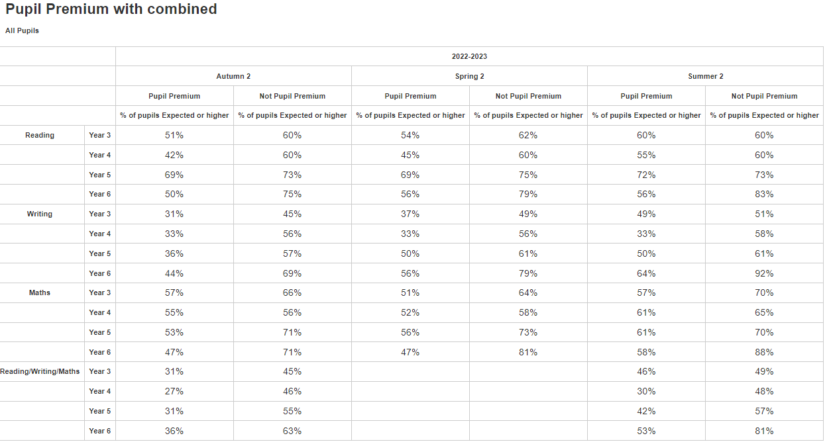
There is evidence of excellent progress in most year groups and subjects. The combined data is low especially in years 4 and 5. Where the percentage of children at expected standard is low, it is indicative of a large number of the PP children also being SEN. These children are making excellent progress in the intervention classes but are unlikely to make it to age related expectations.
The PP data demonstrates good progress in almost all subjects in all year groups. Where the data has stayed the same, this can be attributed to PP pupils joining the school mid-year. The combined (reading, writing and maths) data shows positive progress in all year groups and significant narrowing of the gap between PP and others in all year groups with the exception of year 6. This is due to the late addition of 2 FSM boys with SEN in the summer term.
Combined data gap narrowing Aut-Summer
Year group | Autumn gap | Summer gap
3 | 14% | 3%
4 | 19% | 18%
5 | 24% | 15%
6 | 27% | 28%

Learning walks and lesson visits demonstrated children’s outstanding attitudes to learning.
Parental engagement has improved and it is something that we continue to focus on as a school. Dan Tamblyn is leading on this.
Trips and visits were funded by school for children eligible for FSM if necessary. No child missed out on a trip if they wanted to go.

Externally provided programmes
Please include the names of any non-DfE programmes that you used your pupil premium (or recovery premium) to fund in the previous academic year.
Programme | Provider

Service pupil premium funding (optional)
For schools that receive this funding, you may wish to provide the following information: How our service pupil premium allocation was spent last academic year
The impact of that spending on service pupil premium eligible pupils

Further information (optional)
Use this space to provide any further information about your pupil premium strategy. For example, about your strategy planning, implementation and evaluation, or other activity that you are delivering to support disadvantaged pupils, that is not dependent on pupil premium or recovery premium funding.

