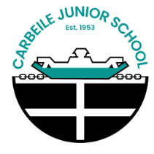 | Carbeile Junior School  Geography Knowledge and Skills Progression
 | Year 3 | Year 4 | Year 5 | Year 6
Locational Knowledge  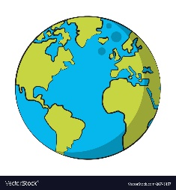 | Name and locate countries of the UK and their capital cities.  Name and locate key counties, cities and geographical regions in the UK.  Identify human and physical characteristics of the UK, key topographical features (including hills, mountains, coasts and rivers) and land-use patterns and how some of these aspects have changed over time. | Name and locate countries of the UK and their capital cities.  Name and locate key counties, cities and geographical regions in the UK.  Name and locate the world’s countries, using maps to focus on South America.  Identify human and physical characteristics, countries and major cities South America.  Identify the position and significance of the Equator and the Tropics of Cancer and Capricorn. | Name and locate the world’s countries, using maps to focus on Europe (including the location of Russia).  Identify human and physical characteristics, countries and major cities in Europe.  Identify the position and significance of latitude, longitude, Equator, Northern Hemisphere, Southern Hemisphere, the Tropics of Cancer and Capricorn, Arctic and Antarctic Circle, the Prime/Greenwich Meridian and time zones (including day and night). | Name and locate the world’s countries, using maps to focus on North America.  Identify human and physical characteristic, countries and major cities in North America.  Identify the position and significance of latitude, longitude, Equator, Northern Hemisphere, Southern Hemisphere, the Tropics of Cancer and Capricorn, Arctic and Antarctic Circle, the Prime/Greenwich Meridian and time zones (including day and night).
Place Knowledge  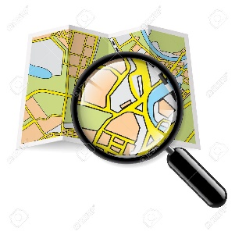 | Understand geographical similarities and differences through the study of human and physical geography of a region of the United Kingdom and the local area. | Understand geographical similarities and differences through the study of human and physical geography of a region of the United Kingdom and South America. | Understand geographical similarities and differences through the study of human and physical geography of a region of the United Kingdom and Europe. | Understand geographical similarities and differences through the study of human and physical geography of a region of the United Kingdom and North America.
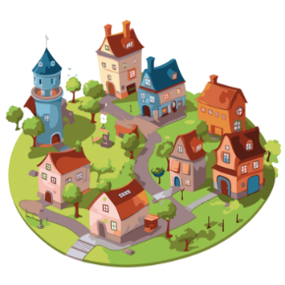  Human Geography | Understand and begin to describe key aspects of:  - human geography including;  Types of settlements and land use. | Understand and describe key aspects of:  - human geography including;  economic activity including trade links and the distribution of natural resources including energy and water. | Understand and describe key aspects of:  - human geography including;  economic activity including trade links and the distribution of natural resources food. | Understand and describe key aspects of:  - human geography including;  land use, economic activity including trade links and the distribution of natural resources including energy, food, minerals and water.
Physical Geography | Understand and begin to describe key aspects of:  - physical geography including;  hills, mountains, rivers, coasts, weather and climate. | Understand and describe key aspects of:  - physical geography including; rivers, climate zones, biomes, vegetation belts and the water cycle. | Understand and describe key aspects of:  - physical geography including;  biomes , vegetation belts and climate zones. | Understand and describe key aspects of:  - physical geography including;  climate zones, biomes, mountains, volcanoes, earthquakes and plate tectonics.
Mapping Skills  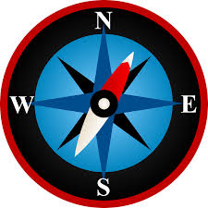 | Use map symbols and keys to locate information.  Use maps, atlases, globes and computer mapping (digimaps) to locate the UK, its countries and our local area.  Confidently use the 4 main compass directions and locational language (North, East, South, West) to build knowledge of the UK and the wider world.  Can use letter and number co-ordinates (not actual grid references to locate features on a map. | Use map symbols and keys to locate information.  Use maps, atlases, globes and computer mapping (digimaps) to locate countries and describe features studied.  Begin to identify 8 points of a compass to follow and give directions to build knowledge of the UK and the wider world.  Can use four – figure grid references to locate features on a map | Use map symbols and keys to locate information.  Use maps, atlases, globes and computer mapping (digimaps) to locate countries and describe features studied.  Confidently identify and use 8 points of a compass to follow and give directions and begin to use longitude and latitude to locate places.  Can confidently use four – figure grid references to locate features on a map and begin to use six-figure grid references. | Use map symbols and keys to locate information.  Use maps, atlases, globes and computer mapping (digimaps) to locate countries and describe features studied.  Confidently identify and use 8 points of a compass to follow and give directions and confidently use longitude and latitude to locate places.  Can confidently use four – figure and six-figure grid references to locate features on a map.
Fieldwork  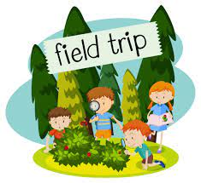 | Use fieldwork to observe, measure and record the human and physical features in the local area using a range of methods, including sketch maps, plans and graphs, and digital technologies.  I know how to present my findings.  Fieldwork – Portwrinkle Beach Coasts Enquiry | Use fieldwork to observe, measure and record the human and physical features in the local area using a range of methods, including sketch maps, plans and graphs, and digital technologies.  I know how to present my findings.  Fieldwork – Local area traffic enquiry | Use fieldwork to observe, measure and record the human and physical features in the local area using a range of methods, including sketch maps, plans and graphs, and digital technologies.  I know how to present my findings.  Fieldwork – School grounds sustainability enquiry | Use fieldwork to observe, measure and record the human and physical features in the local area using a range of methods, including sketch maps, plans and graphs, and digital technologies.  I know how to present my findings.  Fieldwork – Local area changes/development enquiry

