Music Skills Progression
Carbeile Junior School
Area | Year 3 | Year 4 | Year 5 | Year 6
Singing | - Unison songs of varying styles and structures  (Do – so smaller range)  - Perform loud (forte) and quiet (piano)  - Perform actions  - Walk, move or clap a steady beat | - Unison songs of varying styles and structures  (Do – do larger range)  - Get louder (crescendo) and quieter (decrescendo)  - Sing rounds | - Sing a broad range of songs  - Sing rounds (aim for up to 3-parts in round) | - Sing a broad range of songs including those that involve syncopation  - Sing rounds (aim for 3-4 parts in round)
Composing | - Improvise (using voices and instruments)  - Invent short ‘on-the-spot- responses  - Compose in response to different stimuli (e.g. stories, verse, images etc)  - Create rising and falling phrases  - Use note values (see notation in key musical vocabulary below) | - Improvise on an instrument including smooth (legato) and detached (staccato)  - Compose short pentatonic phrases  - Arrange notation cards (see notation in key musical vocabulary below)  - Introduce major and minor chords  - Use graphic scores / rhythm notation / staff notation / technology | - Improvise freely on tuned instruments  - Consider dynamics: very loud (fortissimo), very quiet (pianissimo), moderately loud (mezzo forte) and moderately quiet (mezzo piano)  - Compose a short ternary piece (A B A)  - Create a specific atmosphere or mood  - Use graphic scores / rhythm notation / staff notation / technology | - Improvise with sections  - Use chord changes as part of an improvised sequence  - Plan and compose up to 8- beat melodic phrase using pentatonic scale  - Consider rhythm of phrases  - Compose a short ternary piece (A B A)
Performing | - Begin to use staff notation (see notation in key musical vocabulary below)  - Play phrases fast (allegro) and slow (adagio)  - Introduce the lines and spaces (stave) and the clef.  - Use dot notation to show high and low notes.  - Introduce crotchets, quavers and minims.  - Apply chants to rhythms | - Play and perform melodies following staff notation (see notation in key musical vocabulary below)  - Perform in 2 or more parts | - Play and perform melodies following staff notation (see notation in key musical vocabulary below)  - Understand how triads are formed  (3 notes played at the same time)  - Read and play short rhythmic phrases from prepared cards (see notation in key musical vocabulary below) | - Play and perform melodies following staff notation (see notation in key musical vocabulary below)  - Consider dynamics when performing: very loud (fortissimo), very quiet (pianissimo), moderately loud (mezzo forte) and moderately quiet (mezzo piano)  - Read and play short rhythmic phrases from prepared cards (see notation in key musical vocabulary below)

Listening Suggestions - Year 3
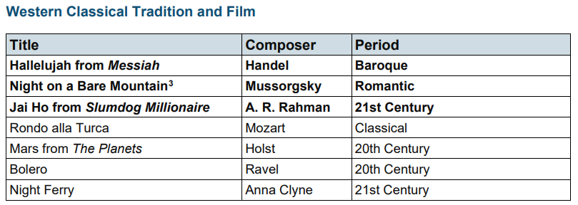

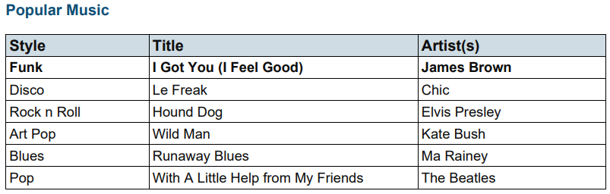

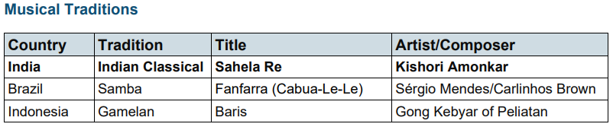

Listening Suggestions - Year 4
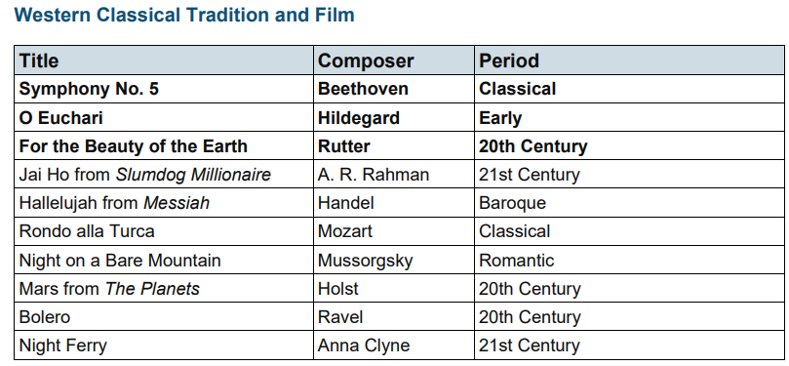

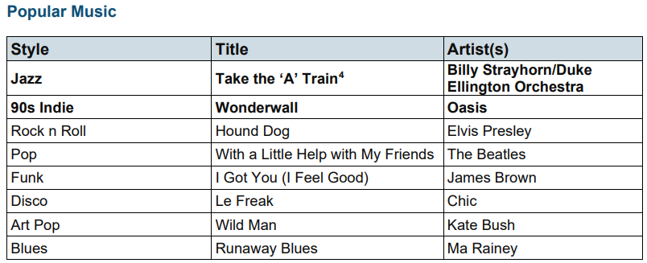

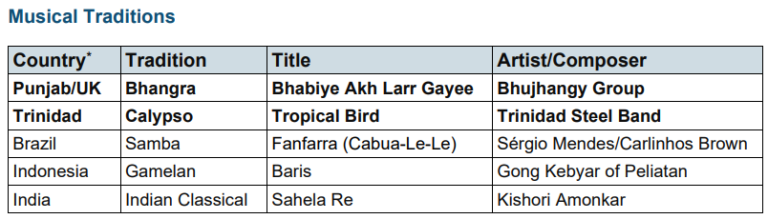

Listening Suggestions - Year 5
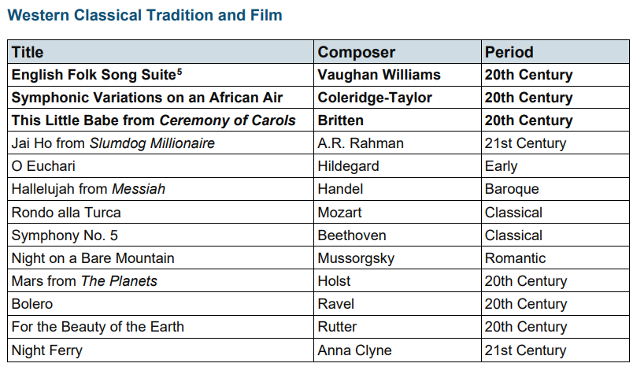
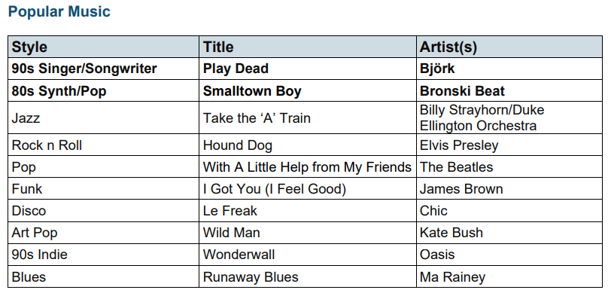
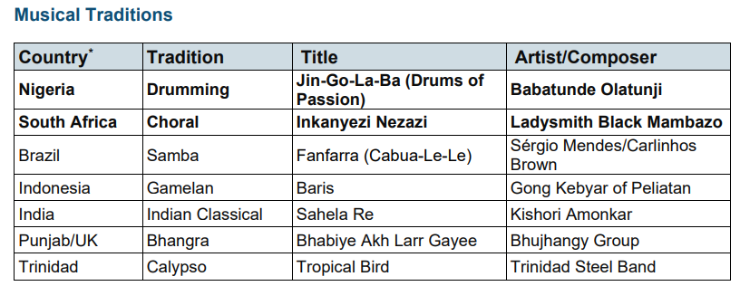
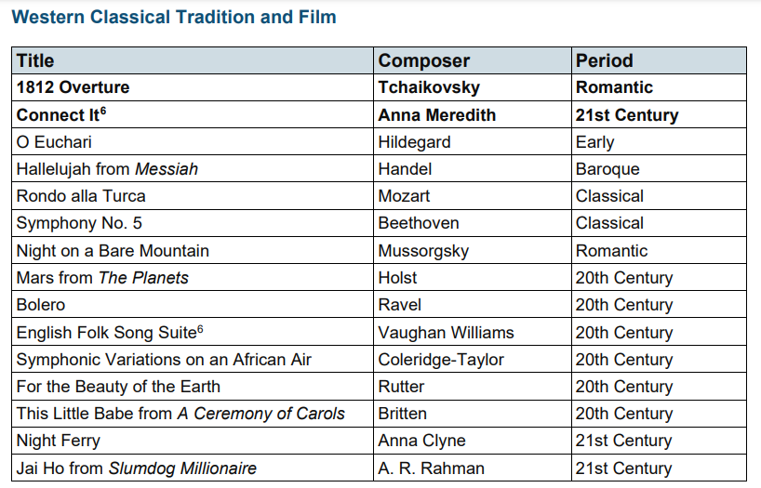
Listening Suggestions - Year 6
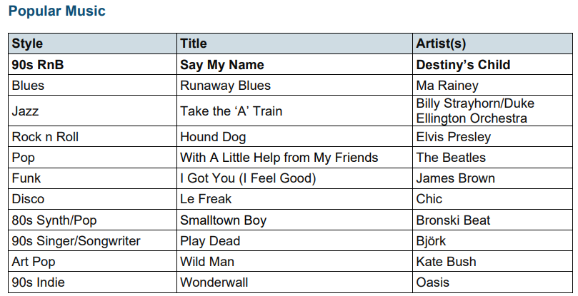

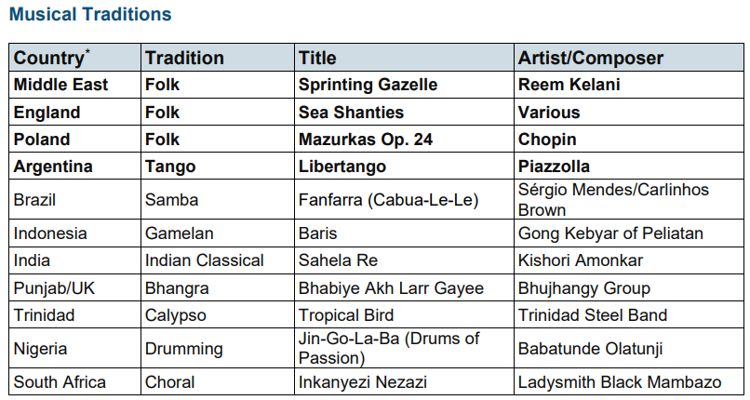

Key Musical Vocabulary
 | Year 3 | Year 4 | Year 5 & 6
Rhythm | Pulse  Beat  Fast (allegro)  Slow (adagio) | Getting faster (accelerando)  Getting slower (rallentando)  Bar | Syncopation
Structure | Call and response  Echo  Ostinato - repeated musical phrase | Rounds  Repetition | Music with multiple sections  Ternary from  (A, B, A)
Texture | Unison | Duet  Melody + accompaniment  Music in parts (Samba band) | Music in 3 or 4 parts
Dynamics | Loud (forte)  Quiet (piano) | Getting louder  (crescendo)  Getting softer (decrescendo)  Smooth (Legato)  Detached (Staccato) | Very loud  (fortissimo)  Very quiet  (pianissimo)
Notation | - Crotchets  - Quavers  - Minims  - Stave  - Clef | - Crotchets  - Quavers  - Minims  - Stave  - Clef  - Rests | - Crotchets  - Quavers  - Minims  - Stave  - Clef  - Rests  - Semibreves  - Semiquavers  - Time signatures  (2/4, 3/4, 4/4)

