Pupil premium strategy statement

This statement details our school’s use of pupil premium (and recovery premium for the 2022 to 2023 academic year) funding to help improve the attainment of our disadvantaged pupils.

It outlines our pupil premium strategy, how we intend to spend the funding in this academic year and the effect that last year’s spending of pupil premium had within our school.

School overview
Detail | Data
School name | Carbeile Junior School
Number of pupils in school | 354
Proportion (%) of pupil premium eligible pupils | 40% (including PLAC/LAC)
Academic year/years that our current pupil premium strategy plan covers | 2021-2023
Date this statement was published | September 2022
Date on which it will be reviewed | July 2023
Statement authorised by | P. Hamlyn
Pupil premium lead | C. Sales
Governor / Trustee lead | S.Morton
Funding overview
Detail | Amount
Pupil premium funding allocation this academic year | £156,070
Recovery premium funding allocation this academic year | £12,760 (88 x £145)
Pupil premium funding carried forward from previous years (enter £0 if not applicable) | £0
Total budget for this academic year  If your school is an academy in a trust that pools this funding, state the amount available to your school this academic year | £168,830

Part A: Pupil premium strategy plan

Statement of intent
Key Principles
- To ensure that teaching and learning opportunities meet the needs of all the pupils and all children receive quality first teaching.
- Ensure that appropriate provision is made for disadvantaged pupils
- In making provision for disadvantaged pupils we recognise that not all pupils who receive free school meals will be socially disadvantaged and we also recognise that not all pupils who are socially disadvantaged are registered or qualify for free school meals. Therefore, we reserve the right to allocate Pupil Premium funding as needed.
Ultimate Objectives
- To address social disadvantage by addressing gaps in pupils’ knowledge and skills
- To narrow the attainment gap between disadvantaged and non-disadvantaged pupils within internal school data
- For all disadvantaged pupils in school to reach age related expectations by the end of Year 6 and thus go on to achieve good GCSEs in Maths and English.
- To provide pastoral support to ensure children feel happy and safe in school and allow them to achieve their full potential.
Achieving these Objectives
- Small class sizes and intervention classes with highly focused teaching Additional learning support – TA in every class
- Pastoral support
- National tutoring programme
- Booster lessons
- Reading buddies
- Pupil Premium Champion to monitor PP children across the school
- Funding trips and visits as required ensuring children have first-hand experiences to use in their learning in the classroom.
- Funding of home learning software
- Behaviour and nurture at lunchtimes
- Attendance incentives

Challenges

This details the key challenges to achievement that we have identified among our disadvantaged pupils.
Challenge number | Detail of challenge
1 | Social barriers and emotional intelligence
2 | Attitudes to learning
3 | Poor literacy skills (especially reading comprehension) and poor vocabulary
4 | Poor numeracy skills
5 | Lack of aspiration
6 | Attendance
7 | Parental engagement
8 | Narrow experiences outside school – cultural capital
9 | Impact of Covid-19

Intended outcomes
This explains the outcomes we are aiming for by the end of our current strategy plan, and how we will measure whether they have been achieved.
Intended outcome | Success criteria
Children are able to talk about their feelings in a controlled way and acknowledge problems can be solved.  The most vulnerable children are safeguarded.  Children’s basic needs are met. | Children retain more friendships and have less fall outs  Children have trusted adults to share worries with.  Children need less support in class time to resolve friendship issues.  Safeguarding is outstanding and all training is up-to-date.  Children do not struggle to concentrate in lessons due to hunger.
Children demonstrate excellent attitudes to learning in all lessons. | Children talk about school with enthusiasm (pupil conferencing).  Children use learning powers to good effect in lessons (lesson visits/drop ins)  Children are engaged and there is no low level disruption in lessons  Children talk about their personal targets with excitement.  Children set/attempt challenging targets.
PP children’s reading and writing improves in line with non-PP children | PP progress in reading is good.  PP children enjoy reading and can talk enthusiastically about a book they are reading.  Children enjoy English lessons (pupil conferencing).  PP achieve in line with non-PP children.
PP children’s maths improves in line with non-PP children | PP progress in maths is good  PP children enjoy maths lessons  PP achieve in line with non-PP children
Children have high aspirations and are ambitious | Children talk about their future with enthusiasm  Children talk about academic targets with excitement  Children attempt challenging targets  Children speak ambitiously about their future at Secondary school and work.  Children are resilient to failure
The attendance of PP children improves | Attendance for PP children is in line with others.  Whole school attendance is at least in line with national at 96%.
Children read more regularly at home and access the library more frequently. Children have the facilities available to do their home learning online. | Parents understand the importance of reading at home.  The number of children reading 3 times a week increases.  Children borrow library books weekly.  Children use Bug Club to access online books.  Parents attend parent meetings
Children are offered experiences by school (subsidised if necessary). | Children gain experiences outside school.  The experiences have an impact on their vocabulary  Children acquire the cultural capital they need to succeed in life.
Gaps in learning due to Covid-19 are addressed and children’s attainment is good. | Children make good progress and 75% meet age-related expectations by the end of the year.

Activity in this academic year
This details how we intend to spend our pupil premium (and recovery premium funding) this academic year to address the challenges listed above.

Teaching (for example, CPD, recruitment and retention)
Budgeted cost: £108,268
Activity | Evidence that supports this approach | Challenge number(s) addressed
Pupil Premium Champion monitoring progress of PP children.  (£10,818) | ‘Ofsted – Disadvantaged Pupils – a concerted effort?’ Successful schools often appoint a senior leader to raise the profile and champion the learning of disadvantaged pupils. | 1-9
SENCO  (£9313) | 23% of SEN are PP. These children have a provision plan and are monitored by the SENCO. | 3 and 6
2 extra teaching assistants per year group – 100 TA hours  (£42,225) | There is a TA in every classroom in the morning. Their deployment is discussed at pupil performance meetings and they target the PP children.  There is no significant gap between the attainment of PP children and others.  Small group tuition (+4 months) | 2, 3, 4 and 9
Regular Safeguarding updates and CPD | Staff are fully informed and can therefore make good decisions and safeguard children effectively. | 1 and 6
4 intervention classes taught by a teacher  (£30,972) | Teachers have higher quality interactions with pupils and give more frequent feedback (+2 months)  Within class attainment grouping (+2 months) | 2, 3 and 4
Regular CPD for English and maths teaching to ensure quality first teaching. Lesson visits and drop ins.  (£500) | Collaboration and sharing of good practice has an impact on quality of teaching.  Focused feedback with areas for development means that teaching improves. | 3 and 4
Phonics screening on entry to Year 3 and comprehension test using PIRA (standardised test)  Reading skills lessons taught 4 times per week.  Bug Club provided for home reading.(£180) | Effective diagnosis of reading difficulties is critical.  Reading comprehension strategies focus on the learners’ understanding of written text. Pupils learn a range of techniques which enable them to comprehend the meaning of what they read.  (+ 6 months) | 3
Year 6 reading buddies  TA to run club at lunchtimes  (£1500) | Peer tutoring has a positive impact on the tutor and tutee.  (+ 5 months) | 3
Learning Powers made explicit in every lesson. | Children are specifically taught learning skills and develop more responsibility for their learning.  (+7 months) | 2 and 5
National Tutoring Programme to improve reading outcomes  (£12,760 exact figure unknown) | Small group tuition (+4 months)  One to one tuition (+5 months) | 3

Targeted academic support (for example, tutoring, one-to-one support structured interventions)
Budgeted cost: £ 21,212
Activity | Evidence that supports this approach | Challenge number(s) addressed
Booster lessons before school  (£6000) | Clear structure with strong links to the curriculum delivered by highly effective teachers.  (+ 3 months) | 3 and 4
Academic interventions (Speech and language, fine and gross motor skills, autism, dyslexia)  (£7319) | Oral language interventions aim to support learners’ use of vocabulary, articulation of ideas and spoken expression +6 months  Small group tuition targeted at pupils’ specific needs. (+4 months) | 3 and 4
Pre-teach of topic vocabulary with a TA  (£2711) | Children who may find vocabulary difficult to understand are more confident in lessons.  (+ 4 months) | 3
Regular trips and visits (subsidised when necessary)  (£4000) | The narrowness of children’s cultural capital has a huge impact on their progress in reading comprehension. | 1, 3 and 8
Subscription to Mathletics, Bug Club and Reading Eggs  (39% £1182) | Home learning tasks linked to classroom work.  Access to high quality texts.  Parental engagement (+4 months)  Homework (+5 months) | 3, 4 and 7

Wider strategies (for example, related to attendance, behaviour, wellbeing)
Budgeted cost: £ 13,473
Activity | Evidence that supports this approach | Challenge number(s) addressed
RSHE lessons delivered weekly | Children need an emotionally safe ethos in the classroom. They will then share concerns with the teacher early on before they become a catalyst for anger. | 1 and 5
Pastoral interventions (Thrive, Lego therapy, MKC)  (£12,973) | Children learn strategies to cope with unhappy feelings and become more engaged in school work. Children are supported in friendships and social interactions so form good friendships.  Social and emotional learning (+4 months) | 1
Attendance awards weekly and termly.  £300 | When children attend school regularly without constant breaks, they make more progress. Evidence shows that children who attend school make better friendships, take more ownership in their learning and are more confident.  Children enjoy receiving awards and will often try harder when an award is being offered. | 6
Regular opportunities for parents to come into school (Learning hours, parent evenings, coffee mornings, assemblies, maths and English workshops) | Parental engagement means that children are supported better. Parents are more likely to support with reading and other home learning tasks.  (+ 4 months). | 7
Science club for PP children, Aspirations day. | Children who are ambitious are more likely to be successful. | 5
Purchase of cereal bars that are available for PP children. (£200) | Children are better able to concentrate on their work if they have eaten breakfast.

Total budgeted cost: £142,953 + £23,450 CIC funding (accounted for separately) = £166,403

Part B: Review of outcomes in the previous academic year

Pupil premium strategy outcomes
This details the impact that our pupil premium activity had on pupils in the 2020 to 2021 academic year.
KS2 SATs data demonstrated that although there is a gap between the attainment of PP children and others, this is reasonably narrow. In fact, in reading and maths the percentage of PP children at greater depth exceeds that of others. This is something to be celebrated as it demonstrates the drive for the more able PP to achieve their potential.
Year 6 SATs data
Average scaled scores, PP compared to others
 | PP | Others
Reading | 103 | 104
GPS | 103 | 104
Maths | 103 | 105

The table below is a comparison between pupil premium children and others at the expected standard (EXS) and greater depth (GD).
 | PP EXS | Others EXS | PP GD | Others GD
Reading | 68% | 70% | 27% | 24%
Writing | 63% | 76% | 7% | 12%
Maths | 71% | 82% | 27% | 20%
GPS | 68% | 74% | 20% | 30%

There is evidence of excellent progress in most year groups and subjects. The combined data is low especially in years 4 and 5. Where the percentage of children at expected standard is low, it is indicative of a large number of the PP children also being SEN. These children are making excellent progress in the intervention classes but are unlikely to make it to age related expectations.

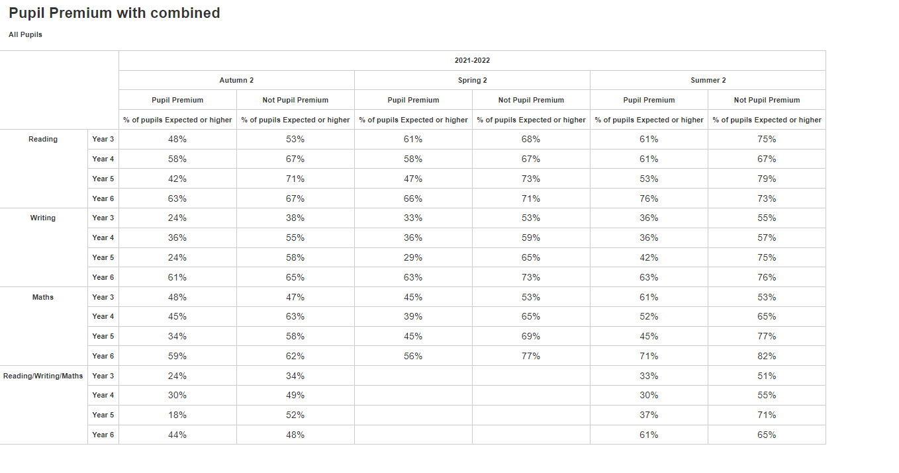
Learning walks and lesson visits demonstrated children’s outstanding attitudes to learning.
Parental engagement has improved since Covid and it is something that we continue to focus on as a school. Dan Tamblyn is leading on this.
Trips and visits were funded by school for children eligible for FSM if necessary. No child missed out on a trip if they wanted to go.

Externally provided programmes
Please include the names of any non-DfE programmes that you purchased in the previous academic year. This will help the Department for Education identify which ones are popular in England
Programme | Provider

Service pupil premium funding (optional)
For schools that receive this funding, you may wish to provide the following information:
Measure | Details
How did you spend your service pupil premium allocation last academic year? | Main spend was on providing pastoral support for children whose parents are serving. Weekly MKC gatherings where children made occasion cards/crafts for families to send away. An opportunity for children to talk to their peers about shared experiences. This is run by a teacher who has been in the military.
What was the impact of that spending on service pupil premium eligible pupils? | Children feel supported and happy to belong to a group where they can openly discuss any problems.

