[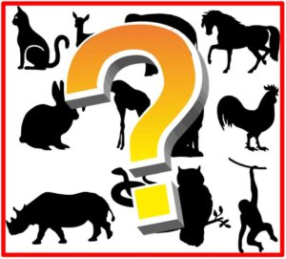](https://www.google.co.uk/url?sa=i&url=http%3A%2F%2Fedtech.wwcsd.net%2F2018%2F03%2Fmystery-animal-a-class-to-class-guessing-game%2F&psig=AOvVaw0BVjnFdZ4eRSnWgAlpPqUQ&ust=1629968619257000&source=images&cd=vfe&ved=0CAcQjRxqFwoTCNi6-Yfpy_ICFQAAAAAdAAAAABAD)

Research an animal of your choice and make a fact file including:

* What they eat
* Description of   
  their teeth
* Where they live

Create a times table   
game for you and your   
friends to play in school.



Make a PowerPoint   
presentation about teeth   
and their role in digestion.



Create 3D teeth made

from any materials   
you have available.

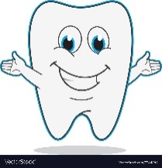

Write or record   
your own rap about  
the digestive system.



**Where Does My Food Go?**

Home Learning Tasks

Create an interesting poster showing how we can brush and look after our teeth.



Complete a survey of your friends and family about their favourite food.

Show your results in either:

1. Pictogram
2. Tally chart
3. Bar chart



This topic will finish on   
**Thursday 21st October 2021**.  
 Please hand in any completed activities before this date.

Create a piece of work about the   
parts of the digestive system.   
You can choose how you   
would like to present your

findings!

