**English**

Write a poem about fire. It can be any type of poetry you like.

**History**

Create a timeline of the Fire of London, include pictures and dates.

**Geography**

Create a map to show the areas affected by the Fire of London.

[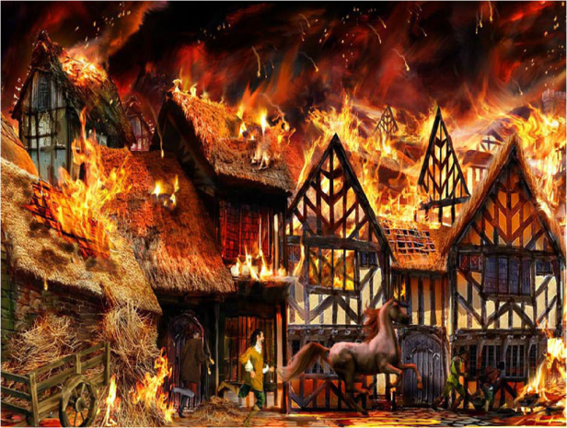](http://www.google.co.uk/url?sa=i&rct=j&q=&esrc=s&source=images&cd=&cad=rja&uact=8&ved=0ahUKEwiL4rTZo_7RAhXBoBQKHQqDBPUQjRwIBw&url=http://www.cliftonprimary.bham.sch.uk/blog/?p=909&psig=AFQjCNE5OUr75sL9gMUk1cVsbE9s9vuimQ&ust=1486566952616857)**The Fire of London**

**Design Technology**

Design and make an item you may find in a bakery. Take a photo or bring it into school to share with your class.

**Art**

Sketch or make a model of a fire. Light your imagination and let your creativity burn!

**Computing**

Design a Scratch programme (you can download this for free) with a Fire of London theme.

**History**

Create a fact file about a significant person from 1666.

Spring Term 2

**Reading**

Write a book review on a book you have read. Remember to read at least 3 times a week for your Reading Ticket!