**English**

Imagine you are in one of the lifeboats after the ship sinking – write your story in first person.

**Outdoor Learning**

With a trusted adult, build a fire and toast some marshmallows / cook some food!

**Geography**

Make a map of Shackleton’s journey. Research the distances travelled between each country.

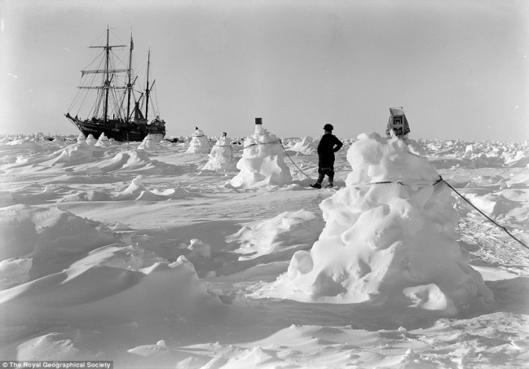**Poles Apart**

**Art**

Using any medium, create a piece of art inspired by the animals that live in the North and/or South Pole.

**Design Technology**

Design and make your own model ship.

**Science**

Make a range of boats out of tin fold. Keep adding cargo (marbles/Lego) until your boat sinks. Create a table to present your results.

**Computing**

Create a leaflet to advertise a Polar cruise. What would you see on the holiday? What might you need to pack?

Spring 1

**History**

Research polar explorers and present your findings in any format.