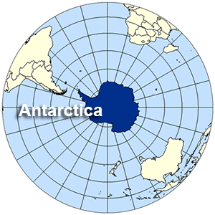
Poles Apart
Spring 1 KIRFs

We have been doing lots of work on long term memory. To assist your child with this, please use these Key Instant Recall Facts (KIRFs) to quiz each other (perfect for a ferry trip).
- Longitude lines are imaginary vertical lines that run from the North to the South Poles and determine our time zones.
- Latitude lines are imaginary lines that run from East to West.
- Lines of longitude and latitude work together to create co-ordinates.
- The Earth is split up into the Northern and Southern hemisphere.
- Lines of latitude: Tropic of Cancer, Tropic of Capricorn, The Equator, Arctic Circle and Antarctic Circle.
- Sir Earnest Shackleton wanted to be the first person to walk across the South Pole but failed.
- The ship he travelled on was called ‘The Endurance’ and it got stuck and crushed in pack ice.
- Shackleton’s family moto was, ‘By endurance we conquer’.
- The whole journey took two and half years.
- Despite treacherous weather and sea conditions ALL the men survived.
- In 1909 Matthew Henson was the first in his party to reach the North Pole but racial prejudice at the time, kept him from receiving credit for his accomplishments.
- Some materials dissolve in water. This means they break apart into tiny pieces, spread out in the water and can no longer be seen. This mixture is called a solution.
- Soluble (will dissolve).
- Insoluble (will not dissolve) .
- Reversible reaction - this is a change that can be undone.
- Irreversible reaction - This is a permanent change (can’t be undone).
- When materials have been mixed together, sometimes it is possible to separate them again (reversible).
- Sieving – used when there is a mixture of different sized solids. For example: sand and pebbles.
- Filtering - used when there is a mixture of liquid and an insoluble solid. For example: water and sand.
- Evaporation - used when there is a mixture of liquid and a soluble solid. For example: water and salt.

