Autumn Term 1 Topic Homework
Choose a minimum of 3 tasks to complete which link to our ‘Space’ topic. We expect you to read 3 times a week and make sure an adult signs your reading record to earn your Golden Ticket. Remember you can access Bug Club books and weekly Mathletics homework is set linked to our maths lessons in school. Your child will also be given a copy of the weekly spellings. Homework will be displayed and merits will be awarded for excellent effort.
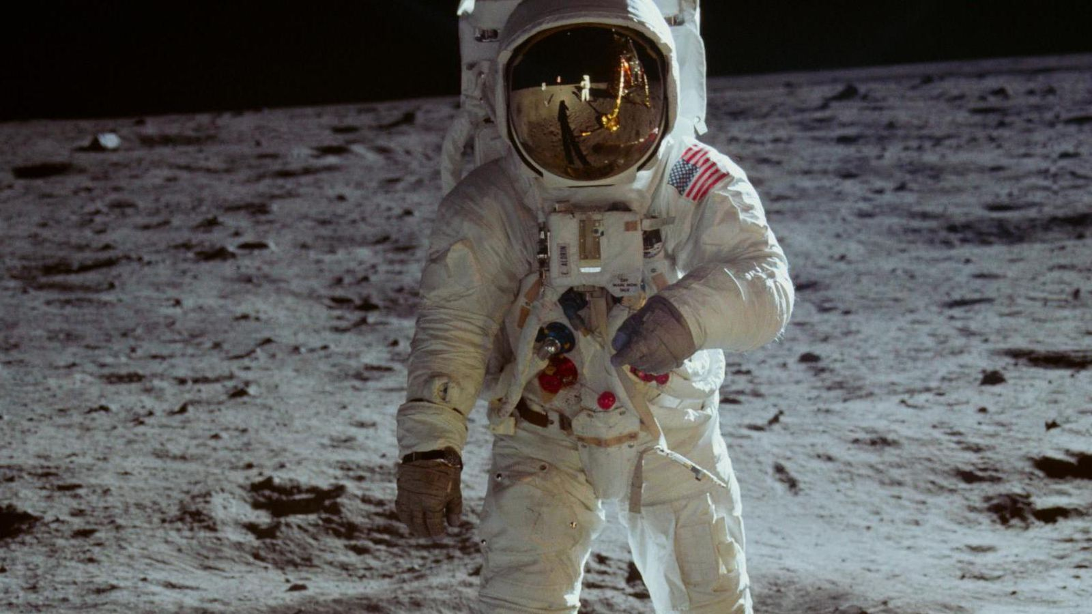
Have fun Year 5!
Make a space model.
Eg. Planet, Moon, Apollo 11, ISS, Solar System.
Make an astronaut meal, take a photo and eat!

Planet Statistics
Distances, diameter etc
Present your data in a table or graph
Space Story
Eg. Alien Adventure
First Woman to the Moon
Lost in Space

Create vocabulary cards with pictures and definitions for our topic words: Sun, Moon, Mercury, Venus, Earth, Mars, Jupiter, Saturn, Uranus, Neptune, spherical, solar system, rotates, star, orbits, planets
Make a presentation about an astronaut
Go Stargazing!
Find and draw the constellations

Create the Solar System
Be creative
Design a space suit and label its features.
Include a new NASA logo.

