Medium Plan: Where Does My Food Go?

Year Group: 4 Term: Autumn 1

Weeks | 06.09.21 | 13.09.21 | 20.09.21 | 27.09.21 | 04.10.21 | 11.10.21 | 18.10.21
Trips  Visitors Special Events | 06.09 – INSET  07.09 - INSET  Topic Launch  Creating 3D teeth from clay + dental team visit  DT | 17.09.21 - SMSC Day Jeans for Genes Day  JM |  |  |  | Showstopper Digestion PPT  (Laptops booked) | Showstopper  Digestion PPT  (Laptops booked)  Computing Day We Are Programmers  21.10.21 – Day taught in 3 topic classes  22.10 – INSET
Maths Intent:

To gain a secure understanding of place value with numbers up to 1,000 and numbers up to 10,000.
To gain a deeper understanding of use written methods for addition and subtraction including exchanging.
Maths | First week back | Number –  Place Value  Week 1  DT | Number –  Place Value  Week 2  RN | Number –  Place Value  Week 3  ET | Number –  Place Value  Week 4  DT | Number – Addition and Subtraction  Week 1  RN | Number – Addition and Subtraction  Week 2  ET
Maths  End Points | Place Value Small Steps:  - Y3 recap: Represent numbers to 1000  - Y3 recap: 100s, 10s and 1s  - Y3 recap: Number line to 1000  - Y3 recap: Find 1, 10, 100 more or less  - Round to the nearest 10, 100 and 1000  - Count in 1000s  - Partitioning  - Number line to 10,000  - 1000 more or less  - Compare numbers  - Order numbers  - Count in 25s  - Negative numbers  - Roman numerals to 100 |  |  |  | Addition + Subtraction Small Steps:  - Add and subtract 1s, 10s, 100s and 1000s  - Y3 recap: Add two 3-digit numbers (up to one exchange)  - Add two 4-digit numbers (up to more than one exchange)  - Y3 recap: Subtract two 3-digit numbers (up to exchanges)  - Subtract two 4-digit numbers (up to more than one exchange)  - Efficient subtraction  - Estimate answers  - Checking strategies
Mathematical Fluency | First week back | Times Table Rockstars  Y4 – 2s + 5s  ILP – 2s | Times Table Rockstars  Y4 – 5s + 10s  ILP – 2s | Times Table Rockstars  Y4 – 2s, 5s, 10s  ILP – 5s | Times Table Rockstars  Y4 – 2s 5s 10s  ILP – 5s | Times Table Rockstars  Y4 – 4s  ILP – 10s | Times Table Rockstars  Y4 – 4s  ILP – 10s
Maths Fluency  End Points | - Year 4: to recall a range of multiplication and division facts for the 2, 5 and 10 times table (recap)  - Year 4: to recall a range of multiplication and division facts for the 4 times table  - ILP group: to recall single multiplication and division facts for the 2, 5 and 10 times table
Writing Intent:
To revisit and become confident with basic skills in sentence construction.
To identify and use a variety of non-fiction features to independently write a non-fiction report on the human digestive system.

Writing | First Week Back | Ready to Write  Unit  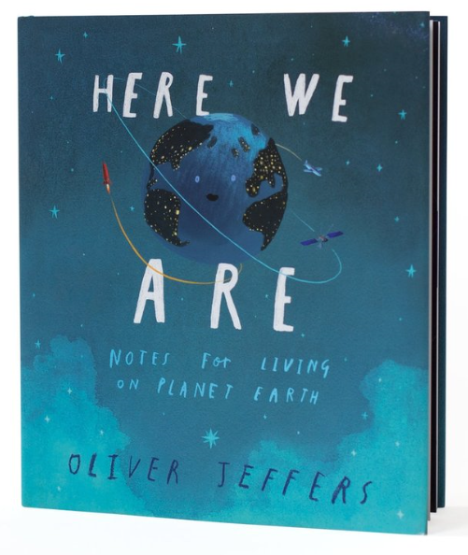  Week 1  ET | Ready to Write  Unit  Week 2  ET  DIVERSITY LINK:  Black Lives Matter Movement | 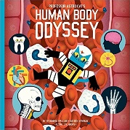  TFW - Human Body Odyssey  Imitate Week  DT | TFW - Human Body Odyssey  Innovate Week  DT | TFW - Human Body Odyssey  Innovate Week  DT | TFW - Human Body Odyssey  Invent Week  DT
Writing  End Points | First Week Back | Ready to Write Unit: (8 lessons)  - Capital letters  - Basic punctuation (. ! ?)  - Nouns  - Adjectives  - Verbs  - Fronted Adverbials  - Coordinating conjunctions  Subordinating conjunctions |  | TFW - Human Body Odyssey:  - Use headings and subheadings  - Use paragraphs to structure ideas  - Use technical vocabulary  - Identify and use adjectives  - Use coordinating conjunctions (but, or, and)  - Begin to use subordinating conjunctions (because, as, after)  Use simple punctuation including ? and !
Reading Intent:
To introduce children to VIPERS and explore vocabulary, inference, prediction, explain, retrieval and summarise.

Reading Skills | Rotation of texts:  First week: Introduction to Science vocabulary - DT  - Demon Dentist - RN  - The Astounding Broccoli Boy - RN  - Are you what you eat? - RN  - Tooth by tooth - DT  - Poetry - DT  - Variety sheets - DT
Reading Skills  End Points | Digestion text:  - Focus on retrieval  - Focus on vocabulary  - Focus on prediction
Spelling Intent:

To identify and correctly use the year 4 spelling rules and patterns.

Spellings | First week back | Week 1  Months of the year  RN | Week 2  Prefix: in, im, ir, il  RN | Week 3  Words that sound like a’sh’ but are spelt with a ‘ch’  Machine  Chef  chalet  RN | Week 4  Words that sound like ‘s’ but are spelt ‘sc’  Scissors  Science  muscle  RN | Week 5  Words with ‘gue’ and ‘que’  tongue  unique  RN | Week 6  Suffix ‘ly’ to create adverbs  RN
Spelling  End Points | 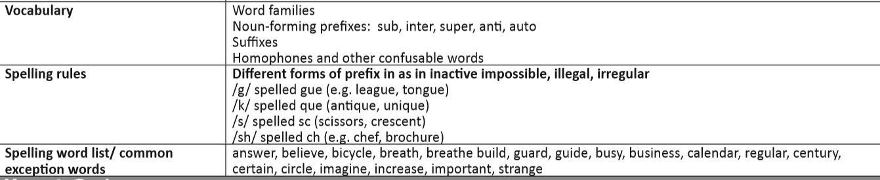
Science Intent:
To gain an understanding of the digestive system in humans and animals and the functions of teeth.
Science  + Investigation x1 | Topic launch:  Children make a clay plasticine model of the bottom row of their teeth  (Lesson 1: Create)  (Lesson 2: Paint)  DT  Identify teeth and their function  DT | Carry out an experiment (eggshells in different liquids)  ET | Identify different parts of the digestive system  ET | Compare the diets of different animals  (Laptops booked)  ET | To investigate the impact of changes to a food chain  ET | Present to others what we know about the digestive system  (Laptops booked)  ET | Present to others what we know about the digestive system  (Laptops booked)  ET
Science  End Points | Working Scientifically  - Ask relevant questions and using different types of scientific enquiries to answer them  - Set up simple practical enquires, comparative and fair tests  - Make systematic and careful observations  - Gather, record, classify and present data in a variety of ways to help answer questions  - Record findings using simple scientific language, drawings, labelled diagrams, keys bar charts and tables  - Report on findings from enquiries, including oral and written explanations, displays or presentations of results and conclusions  - Use results to draw simple conclusions, make predictions for new values, suggest improvements and raise further questions  - Use straightforward scientific evidence to answer questions or to support their findings.  Animals (including humans)  - Describe the simple functions of the basic parts of the digestive system in humans  - Identify the different types of teeth in humans and their simple functions  - Construct and interpret a variety of food chains
Topic Intent:

Art: To learn about the significant artist Giuseppe Arcimboldo and imitate his artistic style.
DT: To carry out an project to design, make and evaluate a fruit smoothie.
Music: To learn and confidently perform a digestion song.
Topic | First week back | Art  Introduction to Giuseppe Arcimboldo.  ET  DT  Favourite fruit bar chart  (Maths link)  DT | Art  Design and plan fruit faces.  ET  DT  Research fruit smoothies.  DT | Art  Design and plan fruit faces.  ET  DT  Design own fruit smoothies.  DT  Music – Introduce the ‘Digestion Song!’ | Art  Create final art face.  ET  DT  Write instructions for smoothies.  DT  Music  Learn the ‘Digestion Song!’ | Showstopper  Individual digestive PPT  (+ basic computer skills)  DT  Make a smoothie!  DT  Music  Learn the ‘Digestion Song!’ | Showstopper  Individual digestive PPT  (+ basic computer skills)  DT –  Evaluate smoothies  DT  Music  Learn the ‘Digestion Song!’
Topic  End Points  (KIRFs) | - The main parts of the digestive system are the mouth, the oesophagus, the stomach, the small and large intestines  - We have 4 main types of teeth: incisors, canines, premolars and molars  - In a food chain is the transfer of energy from organism to another: Producers are organisms who make their own food.  Prey is the animal that gets eaten by the predator. A predator is an animal that eats other animals.  - Giuseppe Arcimboldi was an Italian painter who created portraits made entirely of fruit and vegetables  - Red, yellow and blue are the primary colours and they can be mixed to make secondary colours
Topic Writing  2x cross curriculum writes  1x science investigation |  | Science Investigation  (Egg shells)  ET |  | Instructional writing for smoothies  DT |  |  | Digestion PPTs  DT
Topic Writing End Points | Science experiment:  - Include a heading and subheadings  - Use paragraphs to structure writing  - Use ? after a question  - Include a prediction  - Use time conjunctions |  | Instructional writing for smoothies:  - Include a heading  - Include a clear list of ingredients  - Write simple instructions in chronological order  - Use a range of imperative verbs  - Use a range of fronted adverbials  - Use technical vocabulary  - (Include labelled diagrams) |  |  | Digestive System PPTs:  - Use capital letters and punctuation correctly  - Use a range of verbs  - Use technical vocabulary  - Use headings and subheadings
PE Intent:

To develop collaboration skills within team building games and activities.
To develop invasion games skills in hockey.

PE | Indoor Games  Team building games and activities  Hockey  Dribble with the ball  (Arena) | Indoor Games  Team building games and activities  Hockey  Pass/receive the ball  (Arena) | Indoor Games  Team building games and activities  Hockey  Pass/receive the ball whilst moving  (Arena) | Indoor Games  Team building games and activities  Hockey  Select the best ways to defend  (Arena) | Indoor Games  Team building games and activities  Hockey  Select the best ways to attack+ defend  (Arena) | Indoor Games  Team building games and activities  Hockey  Game play  (Arena) | Indoor Games  Team building games and activities  Hockey  Game play  (Arena)
PE  End Points | Indoor Game  - Listen to and follow a set of rules  - Collaborate with others to join in with games  Hockey  - Control the ball whilst moving  - Accurately pass to peers  - Move into space within game situations  - Look for intercepting opportunities.
RE Intent:
To learn about the major religions and the main principles of beliefs.
RE | People of God  Noah’s Ark | People of God  Noah’s Ark | People of God  The Lord’s Prayer | People of God  The 10 commandments | People of God  Diversity | People of God  Recap of the term | People of God  Recap of the term
RE  End Points  (KIRFs) | - Noah was given instructions by God to create an ark to save his family and examples of all of the world’s animals from a flood  - The Lord’s Prayer is the prayer that Jesus taught his disciples, when they asked him how they should pray  - The Ten Commandments are a fundamental set of rules for Christians to live their life
French Intent:
To learn and use key French vocabulary.
French | Euro Stars  All Aboard  Weather | Euro Stars  All Aboard  Weather | Euro Stars  All Aboard  Days of the week | Euro Stars  All Aboard  Transport | Euro Stars  All Aboard  French pronunciation | Euro Stars  All Aboard  Recap of the term | Euro Stars  All Aboard  Recap of the term
French  End Points | - Explore French language and basic terminology  - Develop oral skills through simple conversations in French  - Understand how to pronounce the French accented letters
RHSE Intent:
To gain an understanding of my place in the class, school and global community as well as devising Learning Charters.
RSHE | First week back | Jigsaw Unit 1: Being me in my world  Piece 1  DT | Jigsaw Unit 1: Being me in my world  Piece 2  DT | Jigsaw Unit 1: Being me in my world  Piece 3  DT | Jigsaw Unit 1: Being me in my world  Piece 4  DT | Jigsaw Unit 1: Being me in my world  Piece 5  DT | Jigsaw Unit 1: Being me in my world  Piece 6  DT
RSHE  End Points | - Understand that my attitudes and actions make a difference to the class team  - Understand who is in my school community, the roles they play and how I fit in  - Understand how democracy works through the school council/in this school  - Understand that my actions affect myself and others  - Understand that my actions affect myself and others  - Understand how democracy and having a voice benefits the school community

DT | JM | ET | RN
Maths  X2 weeks  English T4W Unit  X4 weeks  Reading Skills  3 weeks  DT  6 weeks  RSHE  6 weeks | * Maths  X7 weeks  * English  X7 weeks  * Reading Skills  X7 weeks | Maths  X2 weeks  English Short Unit  X2 weeks  Science  6 weeks  Art  4 weeks | Maths  X2 weeks  Spellings  X7 weeks  Reading Skills  3 weeks

