**Year 4 – Summer Term   
Key Instant Recall Facts**Welcome back! We hope you have all had a lovely, relaxing Easter holiday.   
For the summer term, our new topic will be, ***Why is the Amazon so Amazing?***   
These are some of the main facts we will learn throughout our topic on the Amazon Rainforest and our science unit on living things and their habitats*.* Please practise these KIRFs at home to ensure your child can recall these statements instantly.

[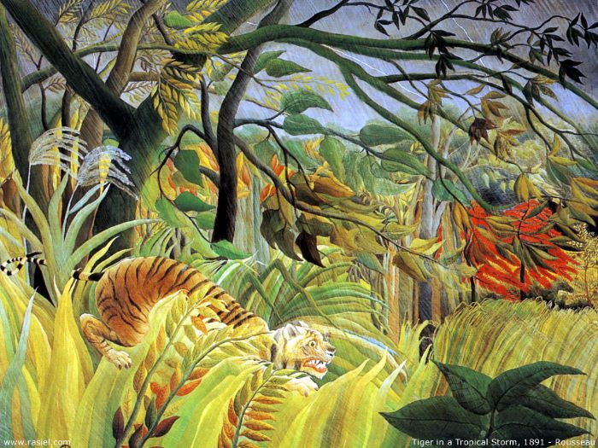](https://www.google.co.uk/url?sa=i&url=https%3A%2F%2Fwww.tes.com%2Fteaching-resource%2Frainforest-art-plan-ks1-11510311&psig=AOvVaw1L_6Wr85FtVjpznFjV-3-E&ust=1618649107514000&source=images&cd=vfe&ved=0CAIQjRxqFwoTCLCprq-wgvACFQAAAAAdAAAAABAE)[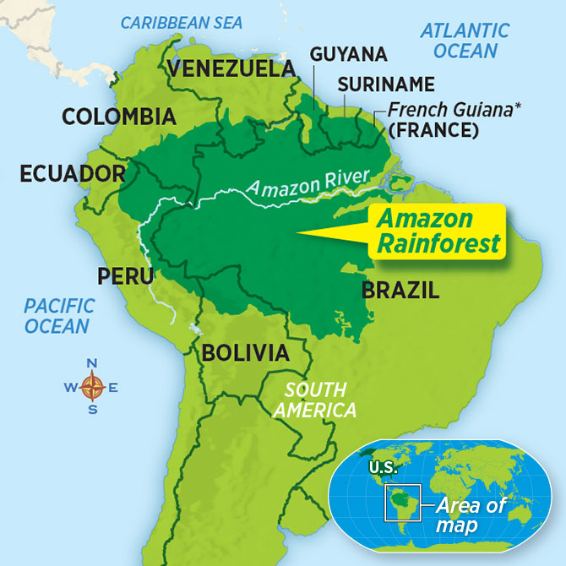](https://www.google.co.uk/url?sa=i&url=https%3A%2F%2Fsn3.scholastic.com%2Fissues%2F2019-20%2F102119%2F5-Big-Questions-About-the-Amazon-Rainforest.html&psig=AOvVaw3pdxJLaElN7g6qR26wvr71&ust=1618648902609000&source=images&cd=vfe&ved=0CAIQjRxqFwoTCOCJ_dGvgvACFQAAAAAdAAAAABAD)[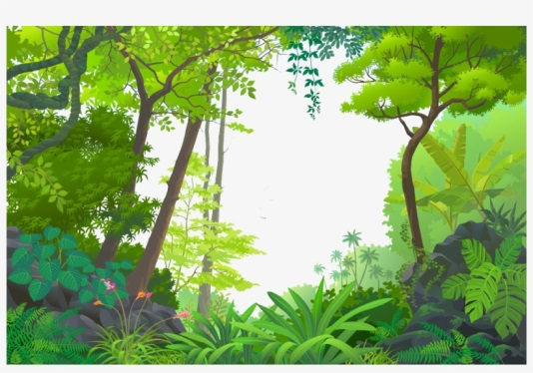](https://www.google.co.uk/url?sa=i&url=https%3A%2F%2Fwww.pngkit.com%2Fview%2Fu2q8y3r5t4t4u2y3_transparent-jungle-euclidean-tropical-rainforest-tropical-rainforest-cartoon%2F&psig=AOvVaw1PSfO4KMPp14mGWWX37V9u&ust=1618648703851000&source=images&cd=vfe&ved=0CAIQjRxqFwoTCPjLq_WugvACFQAAAAAdAAAAABAD)

Carl Linnaeus was   
a Scientist who   
invented classification   
keys to sort organisms.

Henri Rousseau was a French painter who was famous for his jungle paintings.

All living things have 7 characteristics.  
  
TOP TIP: Remember MRS GREN

**M = Movement**

**R = Respiration**

**S = Sensitivity**

**G = Growth**

**R = Reproduction**

**E = Excretion**

**N = Nutrition**

The Amazon Rainforest covers a large area of South America

Rainforests have 4 main layers:

* emergent layer
* canopy layer
* understorey layer
* forest floor layer

