Our Living Planet
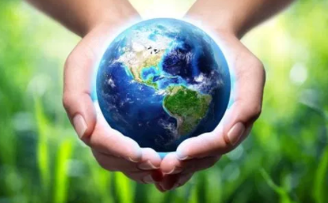
We have been doing lots of work on long term memory. To assist your child with this, please use these Key Instant Recall Facts (KIRFs) to quiz each other (perfect for a ferry trip).
- Life cycle of a bird – egg – hatchling – nestling – fledging – adult
- Life cycle of amphibian (frog) - egg – tadpole – froglet – frog
- Life cycle of mammal – embryo – young – adult
- Life cycle of insect (complete metamorphosis e.g. butterfly) egg – larva – pupa – metamorphosis – adult
- Life cycle of insect (incomplete metamorphosis e.g. dragonfly egg – nymph – adult
- Metamorphosis – when something changes into something else (caterpillar to butterfly)
- Vertebrate – animals with backbones
- Invertebrate – animals with without backbones
- Mammals have fur or hair, skeletons, give birth to live young and mothers produce milk.
- Amphibian means 2 lives, which means they go through metamorphosis.
- Birds have feathers, wings, a beak and lightweight skeletons.
- Not all birds fly.
- Insects have 3 body parts and 6 legs. They have exoskeletons (which is a skeleton on the outside of their body).
- Climate change (or global warming) is the process of our planet heating up.
- The greenhouse effect is a process that occurs when the gases in Earth’s atmosphere trap the Sun’s heat.
- Causes of climate change – burning of fossil fuels, farming, deforestation.
- Effects of climate change – Extreme weathers, changing seasons, shrinking ice caps, rising sea levels, loss of animal habitats.
- Non-renewable energy – fossil fuels such as coal, gas and oil.
- Renewable energy – solar, hydro and wind power.

