**Key Instant Recall Facts (KIRFs)  
Year 4 – Spring 1**These are some of the main facts we will be learning throughout our topic*, How Do You Train a Dragon?*   
Please practise these KIRFs at home to ensure your child can recall these statements instantly by the end of the term.

The Viking period started approximately in 793 AD.

The Anglo-Saxon and Viking era ended in Britain with the Norman conquest in 1066 AD.

The Anglo-Saxons arrived in Britain in 400 AD.

[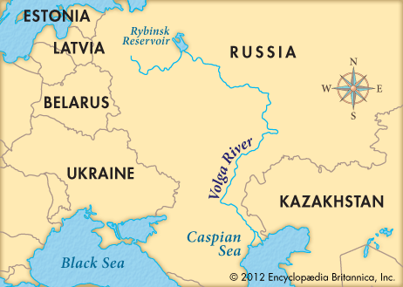](https://www.google.co.uk/url?sa=i&url=https%3A%2F%2Fkids.britannica.com%2Fkids%2Farticle%2FVolga-River%2F346223&psig=AOvVaw2_inCanG2AwHwPLyic8GCU&ust=1581452724095000&source=images&cd=vfe&ved=0CAIQjRxqFwoTCNizw9Tox-cCFQAAAAAdAAAAABAD)[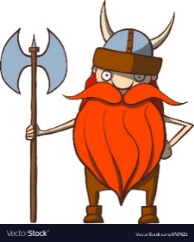](https://www.google.co.uk/url?sa=i&url=https%3A%2F%2Fwww.vectorstock.com%2Froyalty-free-vector%2Ffunny-cartoon-viking-with-an-ax-vector-1767621&psig=AOvVaw0Io4UK-QHCgFw9zAQV0YeL&ust=1581452465326000&source=images&cd=vfe&ved=0CAIQjRxqFwoTCJD939bnx-cCFQAAAAAdAAAAABAD)[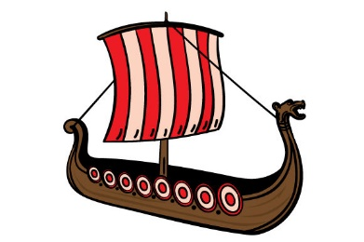](https://www.google.co.uk/url?sa=i&url=https%3A%2F%2Fwww.creativefabrica.com%2Fproduct%2Fcartoon-viking-ship%2F&psig=AOvVaw3nK70DX5HsYCtPM3uQL1zk&ust=1581452967636000&source=images&cd=vfe&ved=0CAIQjRxqFwoTCLDUlcfpx-cCFQAAAAAdAAAAABAO)[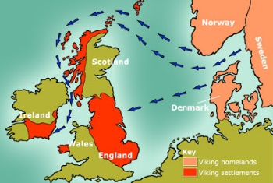](https://docs.google.com/document/d/1p4Xx9dcdM29zut3ZqZ5GesoJEwQpVG6_Qozqg5VMLIs)[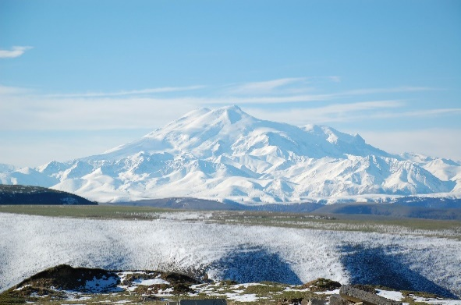](https://www.google.co.uk/url?sa=i&url=https%3A%2F%2Fen.wikipedia.org%2Fwiki%2FMount_Elbrus&psig=AOvVaw0kKDjQy5EScG8zYpVoXy9D&ust=1581452789928000&source=images&cd=vfe&ved=0CAIQjRxqFwoTCLikt_Lox-cCFQAAAAAdAAAAABAD)[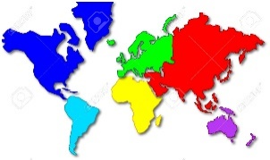](https://www.google.co.uk/url?sa=i&url=https%3A%2F%2Fwww.123rf.com%2Fphoto_3481600_cartoon-style-world-map-showing-the-continents.html&psig=AOvVaw3CVzUEs-ktqldvusmM4K6Y&ust=1581453255058000&source=images&cd=vfe&ved=0CAIQjRxqFwoTCIills_qx-cCFQAAAAAdAAAAABAD)

The Vikings came from   
Scandinavia which is made   
up of Denmark, Norway   
and Sweden.

The Vikings raided for treasure   
and eventually settled because   
of the good farmland in Britain.

The Vikings were great warriors   
and seafarers. They built long ships   
or dragon ships for raiding and war.

A continent is a group   
of countries. A capital   
city is the main seat of   
power in a country   
where governments   
make decisions.

The longest river in   
Europe is the Volga   
in Russia.

The highest mountain in Europe is Mount Elbrus in Russia and it is a dormant volcano.