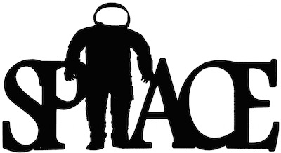

We have been doing lots of work on long term memory. To assist your child with this, please use these Key Instant Recall Facts (KIRFs) to quiz each other (perfect for a ferry trip).

- Order of the planets: Mercury, Venus, Earth, Mars, Jupiter, Saturn, Uranus, Neptune
- Pluto is not a planet. It is a dwarf planet
- The Earth orbits the Sun. The Moon orbits Earth
- The Sun doesn’t move
- The Earth spins on its axis, when it is facing the sun it is daytime, when it is in shadow it is night time
- Earth is tilted on its axis at 23.5 degrees
- The Earth’s seasons are caused by the tilt, position and orbit around the sun
- The phases of the moon: waxing crescent, first quarter, waxing gibbous, full moon, waning gibbous, last quarter, waning crescent, new moon
- Waxing means getting bigger
- Waning means getting smaller
- Apollo 11 Moon landing was in 1969
- Apollo 11 astronauts: Neil Armstrong, Buzz Aldrin, Michael Collins
- Neil Armstrong famously said, “One small step for man, one giant leap for mankind.”

