Poles Apart
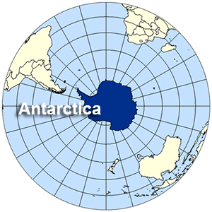

We have been doing lots of work on long term memory. To assist your child with this, please use these Key Instant Recall Facts (KIRFs) to quiz each other (perfect for a ferry trip).
- Longitude lines are imaginary vertical lines that run from the North to the South Poles and determine our time zones.
- Latitude lines are imaginary lines that run from East to West
- Lines of longitude and latitude work together to create co-ordinates.
- The Earth is split up into the Northern and Southern hemisphere.
- Lines of latitude: Tropic of Cancer, Tropic of Capricorn, The Equator, Arctic Circle and Antarctic Circle.
- Lines of longitude: Prime Meridian and International Date Line
- Fold Mountains are formed when two tectonic plates collide and the ground begins to push upwards.
- The features of mountains are; peak, summit, face, slope, plateau and foot.
- Sir Earnest Shackleton wanted to be the first person to walk across the South Pole but failed.
- The ship he travelled on was called ‘The Endurance’ and it got stuck and crushed in pack ice.
- He recruited 28 men and took 69 dogs.
- Shackleton’s family moto was, ‘By endurance we conquer’.
- The whole journey took two and half years.
- Despite treacherous weather and sea conditions ALL the men survived.

