Year 6 Voyage of Discovery Topic – KIRFs
Autumn 2
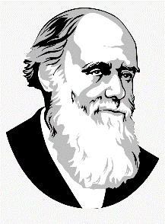
- Adaptation is when animals or plants adapt to suit their environment over a long period of time.
- Charles Darwin came up with a Theory of Evolution, described in his book ‘Origin of Species’.
- He explored the world on HMS Beagle, sailing from Plymouth in 1831.
- The Earth can be divided into Northern and Southern hemispheres by the Equator.
- There are different time zones around the world.
- The Earth comprises several different environments, known as biomes.

