Year 6 Ancient Egyptians Topic – KIRFs
Spring 1
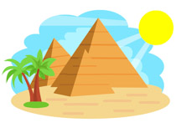
- The Ancient Egyptians lived approximately 5000 years ago until Roman times (30BC).
- Egypt is located in North-east Africa.
- The River Nile runs through Egypt and was vital to Ancient Egyptian life.
- The Ancient Egyptians communicated by using hieroglyphics.
- The Rosetta Stone cracked the hieroglyphic code.
- Howard Carter discovered Tutankhamun’s tomb.
- Dead bodies were mummified and placed in pyramids or tombs to preserve them for the afterlife.
- The Ancient Egyptians worshipped over 2000 gods.

