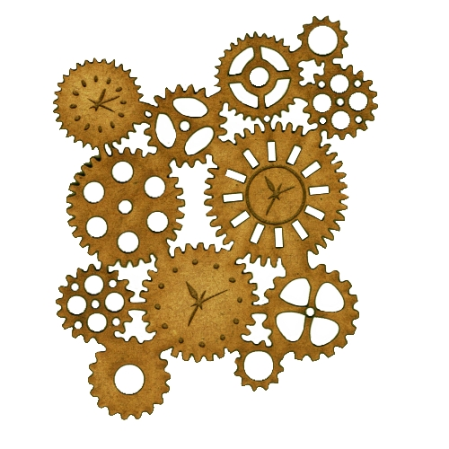**HOW DOES IT WORK?**

**KIRFS (Key information retrieval facts):**

**SCIENCE**

1. A balanced diet is made up of: Proteins (help us grow and repair), Carbohydrates (give us energy), Vitamins & Minerals (keeps us healthy), Dairy (build strong bones & teeth) and a little amount of fats and sugars.
2. We should eat 5 portions of fruit and vegetables a day.
3. Skeletons help the body move, support the body and protect organs.
4. Muscles work in pairs.

**GEOGRAPHY**

1. The United Kingdom is made up of 4 countries: England, Scotland, Wales and Northern Ireland.
2. Cornwall only has one city which is Truro.
3. Cornwall is surrounded by water on three sides.
4. Human features are manmade like buildings and roads
5. Physical features are natural like mountains and rivers.