Appendix 2: Rounding

All year groups will teach rounding using the same strategy to ensure consistency.

Rules for rounding:
- Circle the digit being rounded (the place value).
- Move to the right and underline the digit.
- If the digit is 0-4 the digit in the circle stays the same
- If the digit is 5-9 add one.

Children will need to see visual representations before moving to the abstract. For example:
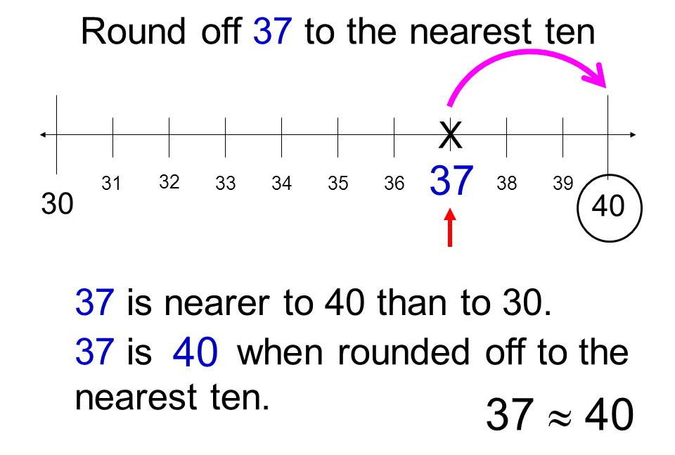
Number lines:

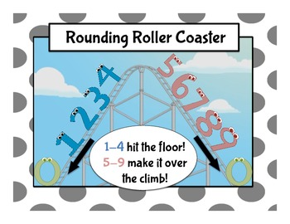
Pictoral representations:

All year groups should use the Rounding Rap: https://www.youtube.com/watch?v=3afU6JQG15I

